Instructions for using the prototype:

1. Open the index page
2. Please select the icon for sitemap. The icon image is given below:



1. After selecting the icon, you will be able to see a dropdown and the prototype map.

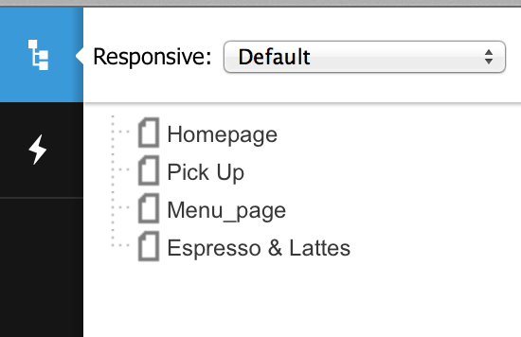

1. Click on the dropdown and select Wide websites and then click on sitemap icon again.

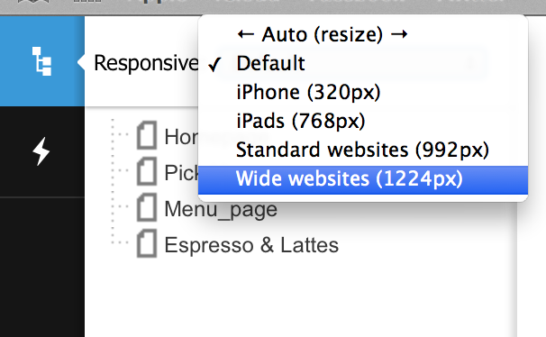

1. Click on “order online

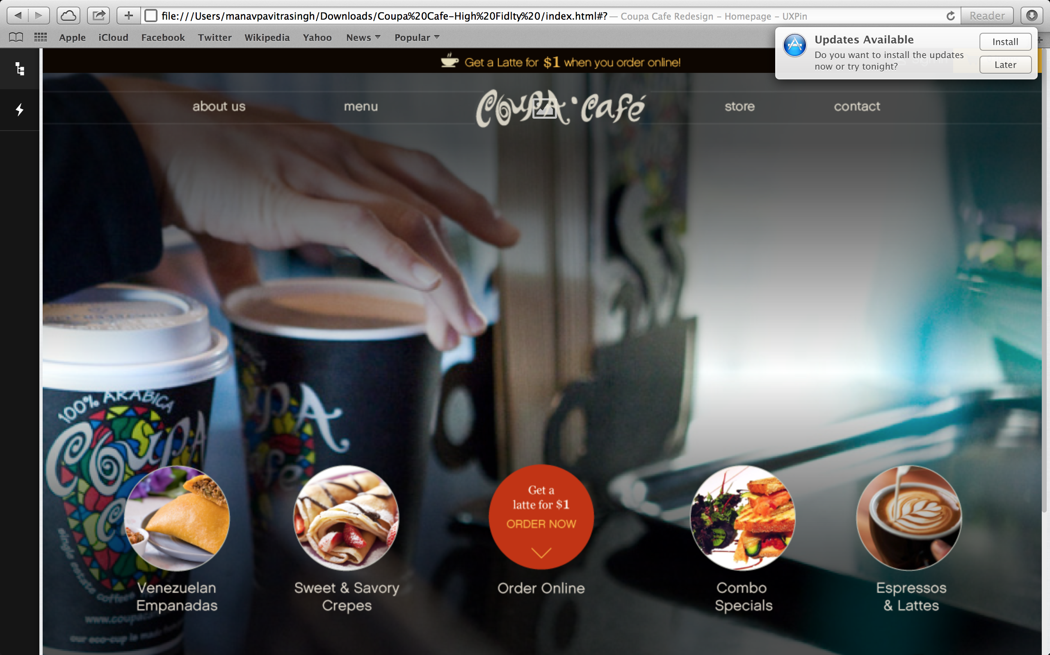

1. Choose Pick up

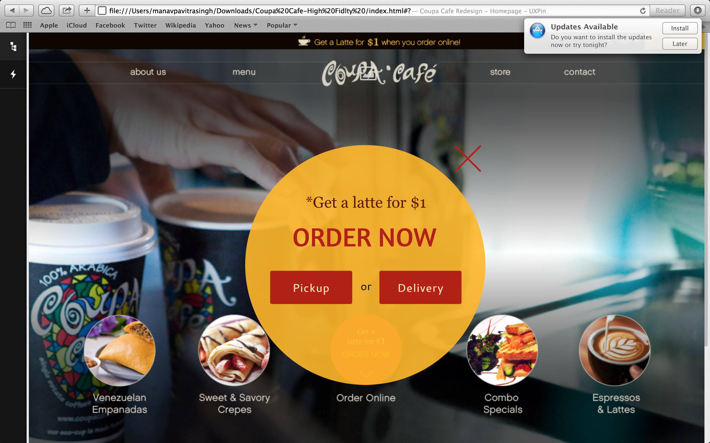

1. Select pickup location as “Stanford” and click on “continue”

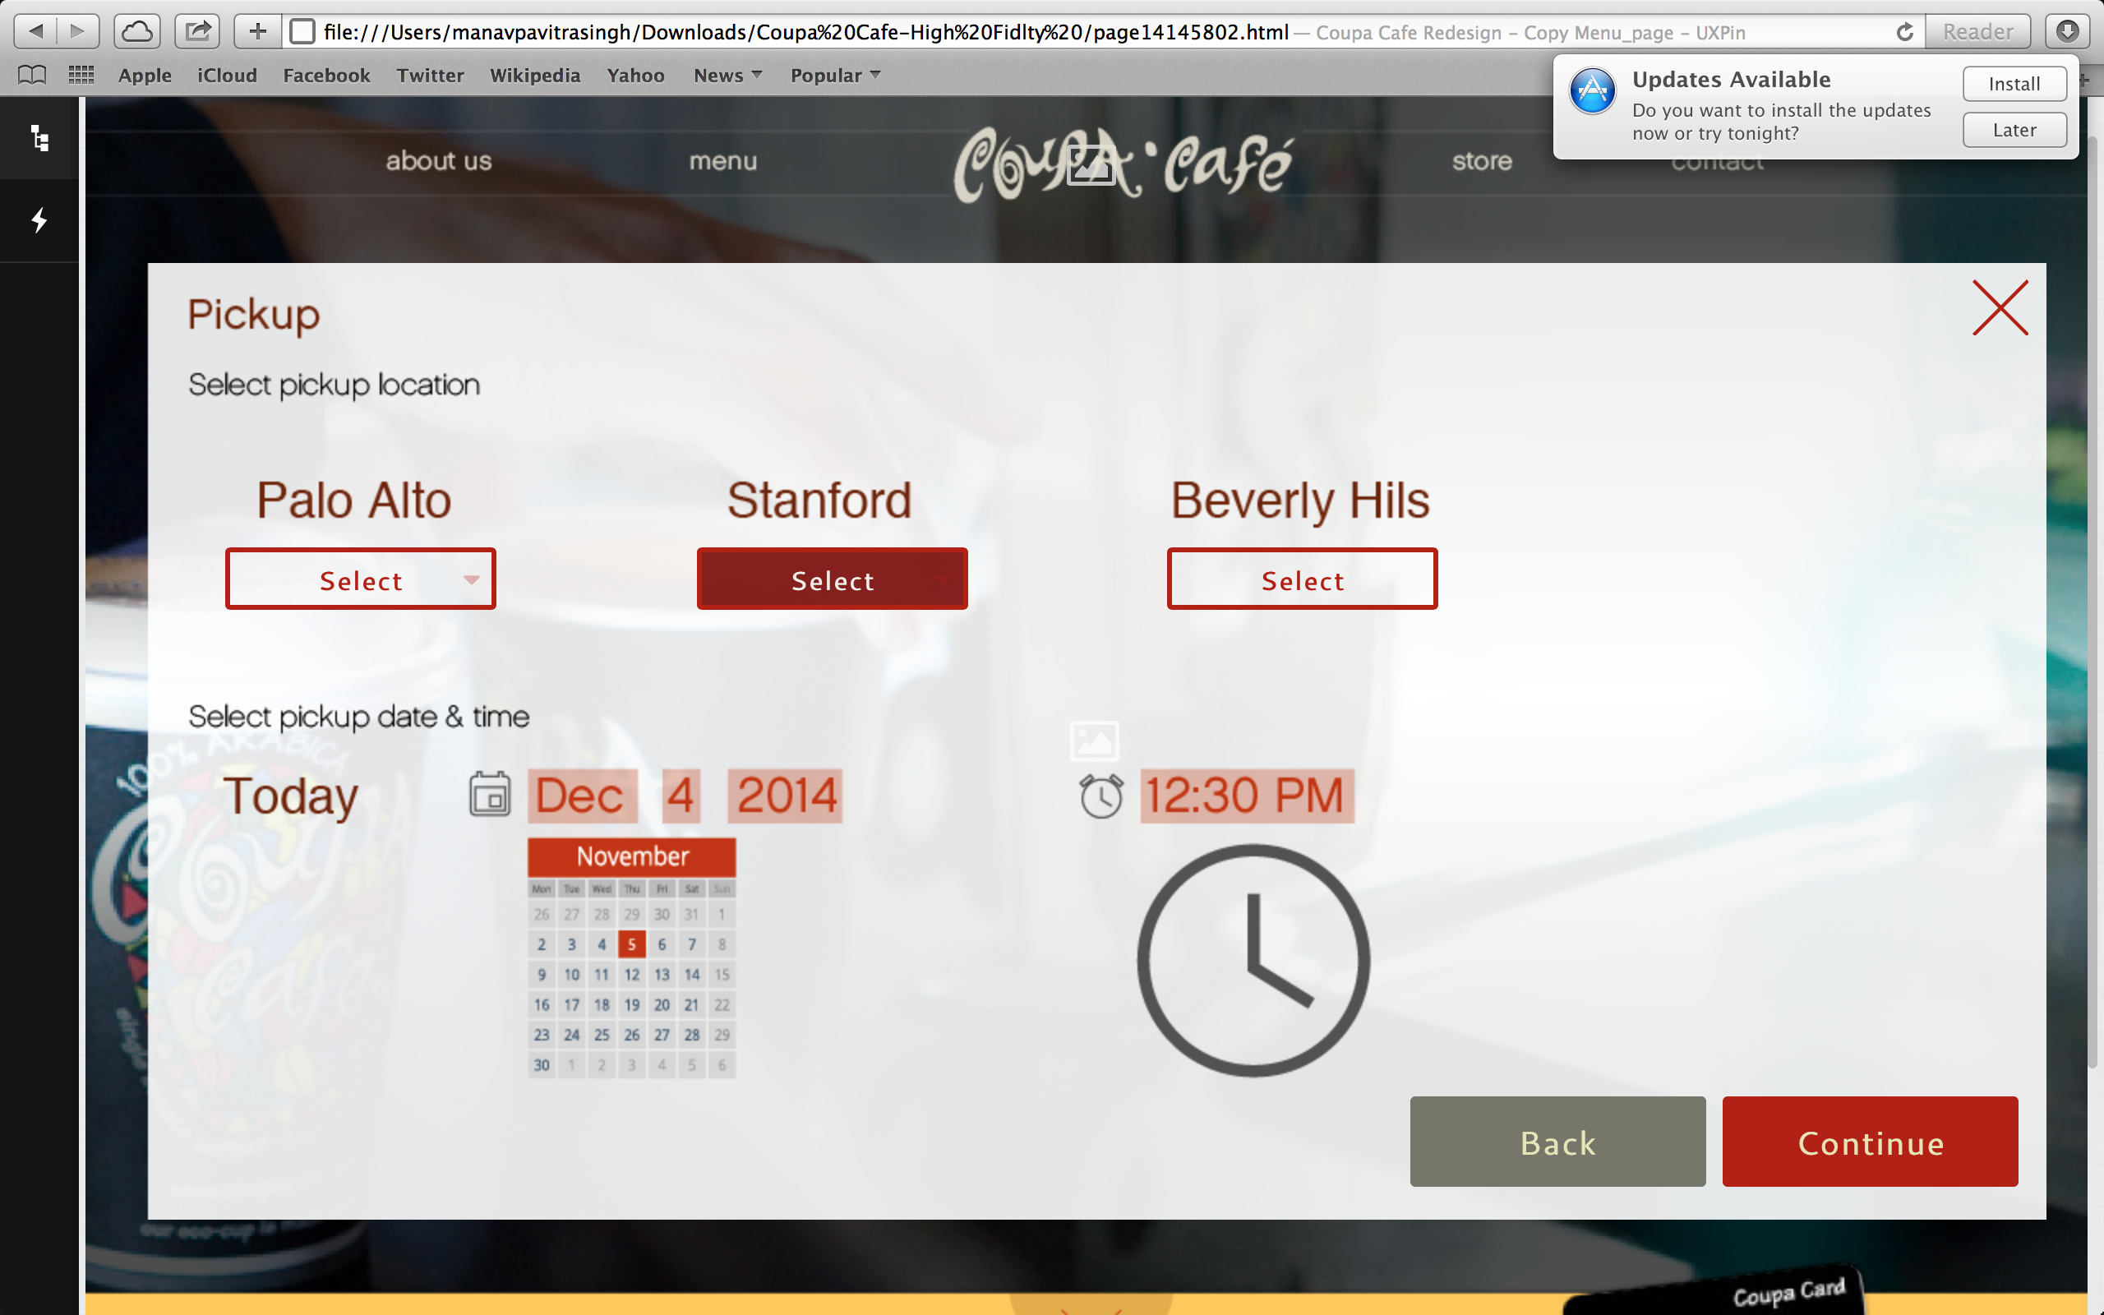

1. Select Espresso and Lattes

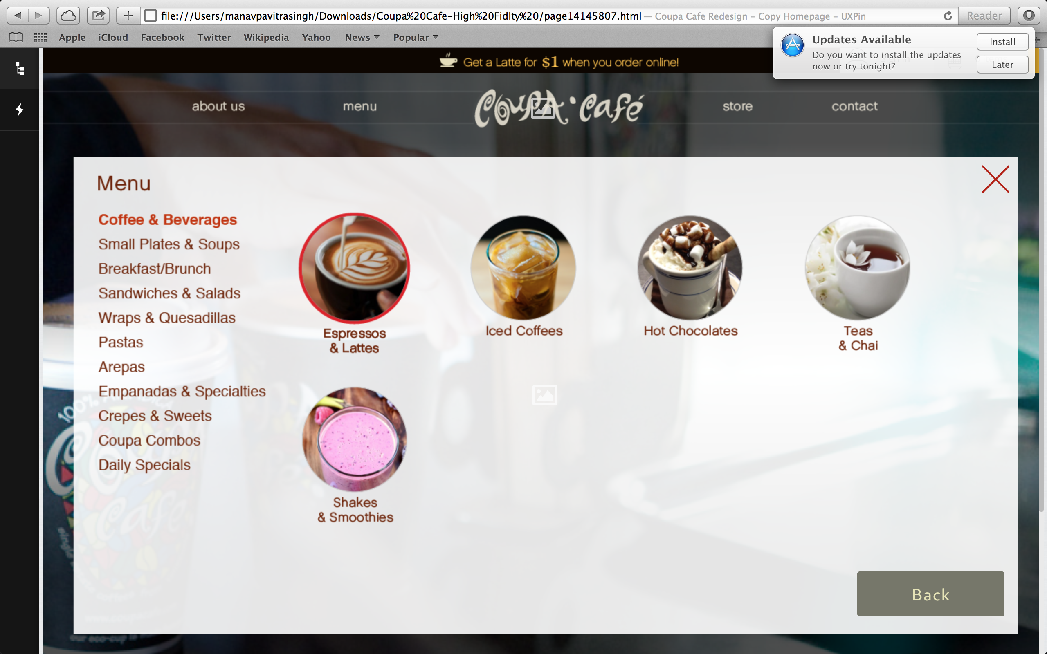

1. Hover over “lattes” and select “Add”

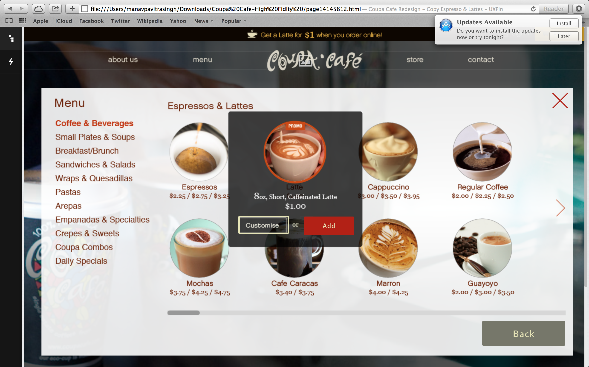

1. Click on “Add” again.

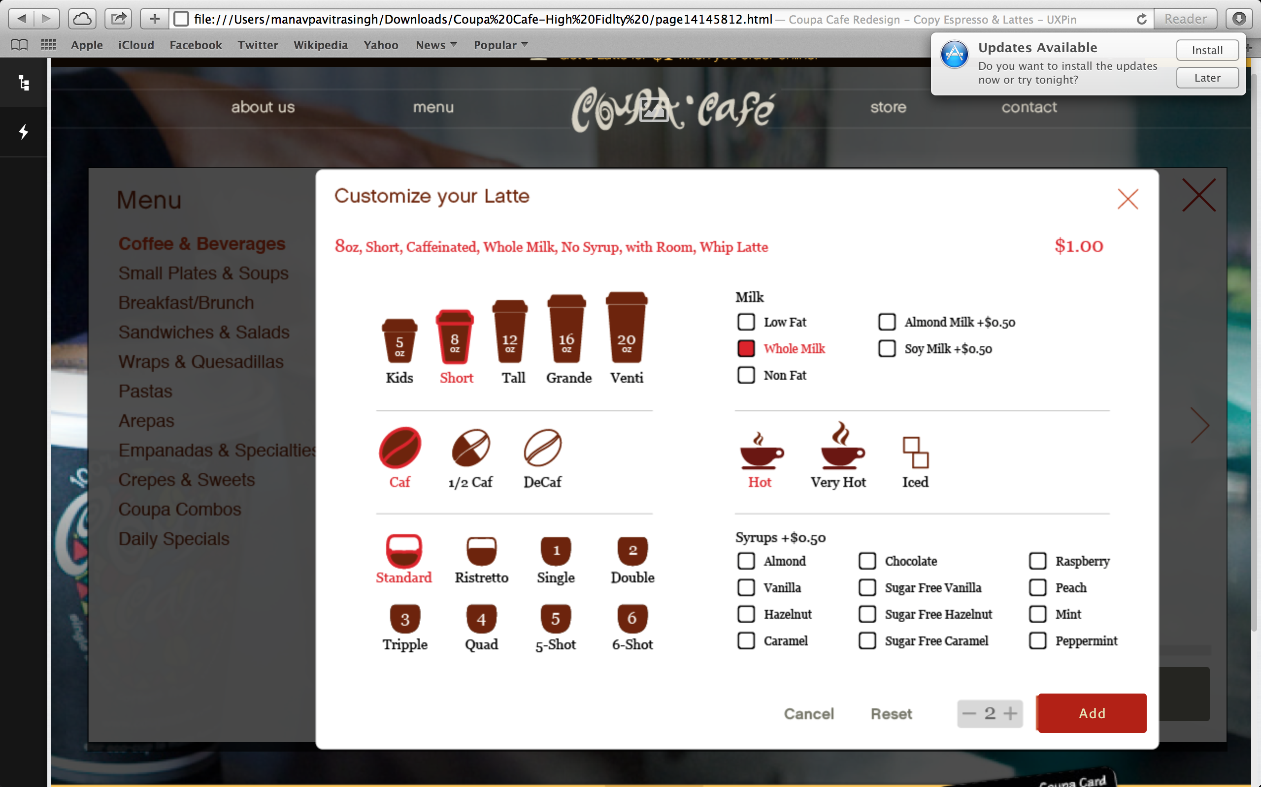

1. And click on order. Your order is ready!

